Introduction to Sociology

Chapter 11 “Immigration and Integration”: Assignments

11.2 International migration

Q1
Go to the Migration Data Portal https://migrationdataportal.org/.
Q1a. How large is the share of the foreign-born population in the Netherlands in 2019 (or, alternatively: in your country or any other country)? Compare this number to neighboring countries: does the Netherlands (your country/etc.) generally have a larger or smaller foreign-born population, in relative numbers?
Q1b. Now find the three largest groups of immigrants in the Netherlands (or other country). You can find this via ‘Immigration and Emigration’. Can you explain historically why people specifically from these countries have migrated to the Netherlands (other country)?
Q1c. Data on migration, such as the data in the Migration Data Portal, often only concerns people with first-hand migration experience: they are the ones registered as moving across borders. Can you think of an immigrant group in the Netherlands (other country) that consists primarily of second-generation immigrants?

Q2.
Suppose two students, cramming for their upcoming Intro to Sociology midterm, get into a discussion. One student argues that ancestry is primarily relevant for people who live in a country with a history of immigration, such as New Zealand or the United States. The other student disagrees and argues that ancestry is also relevant for people living in non-typical immigration countries, such as the Netherlands. Who do you agree with, and why?

11.3 Integration: what does it mean?

Q1
Which dimensions of integration can we discern? Explain what falls under each dimension.

Q2
Can you formulate one descriptive and one theoretical question regarding one dimension of integration?

11.4 Integration: changes over time?

Q1
Suppose a man moves from Poland to Australia in 1946, when he is 17 years old. Due to World War 2, he only finished a few years of school back in Poland. Once in Australia, he starts out by working on a farm, trying to make enough money to support himself. Slowly, he expands his knowledge on how to take care of the animals there. The owner of the farm notices his improvements and suggests a few courses at a local college to improve his knowledge on how to take care of animals. He completes the courses successfully, and the owner of the farm starts telling other farmer friends about his model employee who does his work so efficiently. After a few years, the man starts a business in animal care, which he works at until he retires aged 70 with 5 employees.
Q1a. Which domain of integration does this story primarily concern? What behavior indicates integration?
Q1b. Is this an example of a life course effect or generation effect? Argue why you think this. Also give an example of what the other type of effect would look like in this story.
Q1c. Are the findings of this story in line with the immigrant integration proposition? Argue why (not).
Q1d. Are the findings of the story confirming the immigrant assimilation proposition? Argue why (not).

11.5 Integration: social context effects?

Q1
Consider the three largest immigrant groups in the United Kingdom in 2017 on the Migration Data Portal (https://migrationdataportal.org/?i=groups&t=2017&cm49=826): 874,000 Polish, 836,000 Indian and 529,000 Pakistani immigrants.
Q1a. Which immigrant group(s) would you expect to socially integrate the most easily, based on group size?
Q1b. Which immigrant group(s) would you expect to socially integrate the most easily, based on cultural characteristics of these three groups?

11.6 Culture of honor

Q1
The case study in Chapter 11 is about the difference in cultures of honor in the North and South of the US, how they have emerged historically because of the interplay between immigrant origin cultures and institutional changes in the North and South.
Q1a. Summarize the case study about honor culture in the United States in a theory scheme. There are different possibilities, depending on which part of the case study you focus. What is important that your theory is coherent, such that the observation (O) can be logically derived from the proposition (P) and the condition (C).
(P)
(C)
--------------------------------------------------------------------------------------------
(O)

Q1b. What is the social context effect in your theory scheme? Does it relate to ethnic origins or receiving contexts?

11.7 Integration: selective or spillover effects?

Q1
Carefully read the following case. For both cases, determine whether we can speak of selective integration or whether it is an example of an integration spillover effect.
Case 1: Jan in Nigeria. Jan is a Dutch expat, who lives in Nigeria with his wife and two kids. He works as a manager for an oil company where he has many other Dutch colleagues. After work, the families often meet up so the children can play together. They live in a gated community together and keep in touch with Dutch news and entertainment through satellite connections. The community shop sells typical Dutch foods and products such as ‘hagelslag’ and ‘stroopwafels’, so nobody has to leave the community to do their shopping. Jan does not consider to change his religion and values, to adapt a worldview that is more similar to what is common in Nigeria.
Case 2: Karima in the US. Karima is a female immigrant to the US. Her parents are from Egypt and moved to the US with her when she was 6 years old. She has never been back to Egypt since. She studied law at university and made many friends there, divided about equally between multiple other minorities as well as European Americans. She is currently engaged to her Irish-Italian American fiancé. At home she speaks English with her fiancé, which makes her fluent in English. She also speaks Arabic very well, although not fluently. Her favorite family tradition is celebrating Thanksgiving, which she acquired from her fiancé. Karima identifies herself as Muslim, but she wears no headscarf anymore after she met her fiancé.

11.8 The dynamics of residential segregation

Q1
Q1a. How strong is ethnic residential segregation in your country? Are there differences between ethnic groups in their degree of segregation? Which groups are most segregated?
Q1b. What do you think can explain these patterns of segregation?

Chapter generic questions

Q1
For this web-based question, we are looking at a simulation called “The parable of the polygons” which can be found here: https://ncase.me/polygons/. This simulation shows an adaptation of the Schelling segregation model. Think back to the process of group segregation that was discussed in chapter 8, as well as the discussion of residential segregation in Chapter 11. Multiple processes were explained that influenced the emergence of segregation. Play the first few games until you finish the first simulation under “run this simulation a few times. what happens?”.
Q1a. Which processes are at play in the decision for squares and triangles to move? How do these processes take shape in the games?
Q1b. Play the next two games, until you finish the second simulation under “use the slider to adjust the shapes' individual bias”. How would you fill in the micro-level conditions and outcomes in the following scheme, to represent the story of the games?
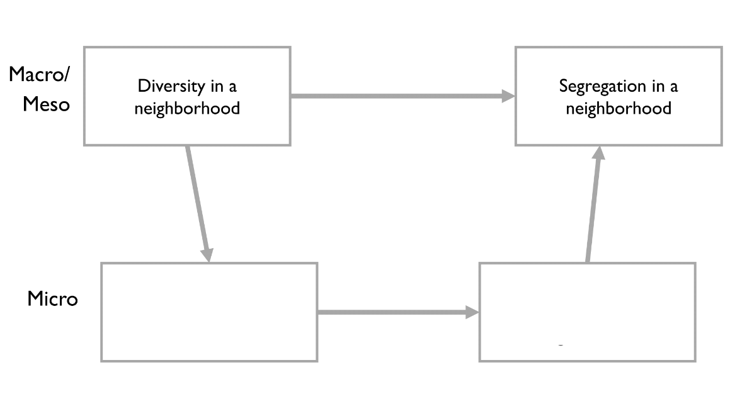
Q1c. What kind of micro-to-macro aggregation takes place here? Simple or complex?
Q1d. Chapter 11 refers to hyper-segregation as levels of segregation above 60%. Play around with the second simulation for a while. Can you figure out the threshold of preferences after which hyper-segregation is the common outcome?
Q1e. Now play the final two simulations (so not the sandbox just yet!). Can you translate the findings from the final simulation to a real-world policy implication?

Q2
Read the following article, published in The Conversation: https://theconversation.com/banning-faith-schools-is-no-quick-fix-to-social-segregation-38797
Q2a. Which dimensions of integration are considered to be problematic among students at faith schools, according to this article? Give an example of the problematic aspect for both.
Q2b. What policies are mentioned in the article to improve levels of integration between faith school students and other students?

