Introduction to Sociology

Chapter 11 “Immigration and Integration”: Assignments with answers

11.2 International migration

Q1
Go to the Migration Data Portal https://migrationdataportal.org/.
Q1a. How large is the share of the foreign-born population in the Netherlands in 2019 (or, alternatively: in your country or any other country)? Compare this number to neighboring countries: does the Netherlands (your country/etc.) generally have a larger or smaller foreign-born population, in relative numbers?
Answer:
For this, select from Immigration and Emigration ‘international migrant stock (%)’, and then select your country. Netherlands: 2.3 million (13.4%). Germany 13.1 million (15.7%). Belgium 2 million (17.2%).
Q1b. Now find the three largest groups of immigrants in the Netherlands (or other country). You can find this via ‘Immigration and Emigration’. Can you explain historically why people specifically from these countries have migrated to the Netherlands (other country)?
Answer:
In the case of Turkish and Moroccans in the Netherlands, the primary reason for migration would be the recruitment of ‘guest workers’ from the 1960s onward. In the case of Surinam this is due to the colonial past.
Q1c. Data on migration, such as the data in the Migration Data Portal, often only concerns people with first-hand migration experience: they are the ones registered as moving across borders. Can you think of an immigrant group in the Netherlands (other country) that consists primarily of second-generation immigrants?
Answer:
Any migration flow that has largely ended several decades ago. (Suriname, Antilles, Indonesia)

Q2.
Suppose two students, cramming for their upcoming Intro to Sociology midterm, get into a discussion. One student argues that ancestry is primarily relevant for people who live in a country with a history of immigration, such as New Zealand or the United States. The other student disagrees and argues that ancestry is also relevant for people living in non-typical immigration countries, such as the Netherlands. Who do you agree with, and why?
Answer:
Both students may be right, depending on the explanation given. The concept of ancestry is primarily used in historical immigration countries to delineate the origins of ancestors. In these nations, ethnic identification does not overlap as much with national boundaries, so that one can be both American and be of Irish and Norwegian ancestry. The core necessity here is that the person identifies with these ethnic groups: That is what makes ancestry relevant. While in the Netherlands for example, a person may descend from the Huguenots, this group is often not identified with since ethnic identification primarily happens along the borders of nation states in countries without a history of immigration. This would thus be an explanation in favor of the first student.
However, in line with the argument of the second student, increasing immigration to these countries in recent years may increase the salience of the concept of ancestry there: A third-generation Moroccan-Congolese-Belgian may find it very important to identify with all ethnic groups they belong to, while a second-generation Surinamese-Dutch person may primarily identify as Dutch. While not as widespread in these countries, individuals may thus still place importance on their ancestry. In this way, it is dependent on an individual’s identification, and not their country of residence, whether ancestry is relevant beyond the categorization along lines of nationality.

11.3 Integration: what does it mean?

Q1
Which dimensions of integration can we discern? Explain what falls under each dimension.
Answer:
The different dimensions are social integration (e.g., interactions with other groups, interethnic attitudes), cultural integration (e.g., ethnic group differences in norms, values and practices), and economic integration (e.g., inequality between ethnic groups in education, labor market positions, health).

Q2
Can you formulate one descriptive and one theoretical question regarding one dimension of integration?
Answer:
For example, descriptive questions in the cultural domain could take the form of: “Do sex role attitudes differ between the native French and Maghreb minorities?”, and a theory question in the economic domain could be: “Why do second-generation immigrants generally leave school with lower qualifications than their native peers?”

11.4 Integration: changes over time?

Q1
Suppose a man moves from Poland to Australia in 1946, when he is 17 years old. Due to World War 2, he only finished a few years of school back in Poland. Once in Australia, he starts out by working on a farm, trying to make enough money to support himself. Slowly, he expands his knowledge on how to take care of the animals there. The owner of the farm notices his improvements and suggests a few courses at a local college to improve his knowledge on how to take care of animals. He completes the courses successfully, and the owner of the farm starts telling other farmer friends about his model employee who does his work so efficiently. After a few years, the man starts a business in animal care, which he works at until he retires aged 70 with 5 employees.
Q1a. Which domain of integration does this story primarily concern? What behavior indicates integration?
Answer:
The integration primarily concerns the economic domain as the man increases his levels of education and starts his own business where he employs multiple people.
Q1b. Is this an example of a life course effect or generation effect? Argue why you think this. Also give an example of what the other type of effect would look like in this story.
Answer:
This is an example of a life course effect, as the process of integration unfolds within someone’s generation. A generation effect would exist, if, for example, his daughter, driven by her father’s love for animals, decides to go to university and becomes a veterinarian, later starting her own veterinarian practice. This would be a case of upward social mobility and gradual convergence to majority positions that occurs across generations.
Q1c. Are the findings of this story in line with the immigrant integration proposition? Argue why (not).
Answer:
This example fits well the immigrant integration proposition, because the man increases his, in this case, economic integration the longer he stays in Australia.
Q1d. Are the findings of the story confirming the immigrant assimilation proposition? Argue why (not).
Answer:
The immigrant assimilation proposition posits that over time ethnic minority and majority groups become indistinguishable. While economically, the Polish immigrant does not differ much from non-immigrants (except perhaps his lower levels of general education), he might still speak Polish at home, and primarily interact with other Polish immigrants. He may attend Polish church services, have married a Polish woman, and may have raised his children in the Polish culture. We can thus not say he is assimilated based on the information provided.

11.5 Integration: social context effects?

Q1
Consider the three largest immigrant groups in the United Kingdom in 2017 on the Migration Data Portal (https://migrationdataportal.org/?i=groups&t=2017&cm49=826): 874,000 Polish, 836,000 Indian and 529,000 Pakistani immigrants.
Q1a. Which immigrant group(s) would you expect to socially integrate the most easily, based on group size?
Answer:
According to Blau’s structural opportunity theory (Chapter 8), group size constraints chances of meeting out-group members. Based on group size, therefore, Pakistani immigrants would be expected to integrate most easily socially. They are the smallest group in terms of size, leading to a higher likelihood of developing group-bridging ties compared to group-bonding ties. This is an element of social integration. In addition, one may use group threat theory (Chapter 8) to arrive at the same conclusion: larger immigrant groups are seen as more threatening to the majority population (in terms of competition of scarce resources, such as jobs and houses, but also culturally). Therefore, Pakistani immigrants, other things being equal, would be perceived as less threatening than Poles, and more group-bridging ties are therefore expected in the Pakistani group.
Q1b. Which immigrant group(s) would you expect to socially integrate the most easily, based on cultural characteristics of these three groups?
Answer:
Depends on the reasoning. When considering cultural characteristics of groups, one could relate this to the tie-formation processes of homophily: the more similar two individuals are, the more likely they are to establish (friendship) ties. Then, it is key to consider various dimensions of homophily. For example, one may elaborate on the role of religion and language. If one considers religion, then one could argue that Polish immigrants most easily integrate socially, because their (Catholic) Christian religious values and practices are more similar to British (mainly Protestant) Christian religion than are the dominantly non-Christian religions from Pakistan and India. If one considers language, however, then one may argue that Pakistani and Indian immigrants may integrate more easily socially, since colonial influence of the UK on these countries means language use already converged to some degree prior to immigration.

11.6 Culture of honor

Q1
The case study in Chapter 11 is about the difference in cultures of honor in the North and South of the US, how they have emerged historically because of the interplay between immigrant origin cultures and institutional changes in the North and South.
Q1a. Summarize the case study about honor culture in the United States in a theory scheme. There are different possibilities, depending on which part of the case study you focus. What is important that your theory is coherent, such that the observation (O) can be logically derived from the proposition (P) and the condition (C).
(P)
(C)
--------------------------------------------------------------------------------------------
(O)

Answer:
One example is the following theory scheme:
(P) The more third-party law enforcement in a region, the less common a culture of honor.
(C) In the 19th century, third-party law enforcement emerged more strongly in the North of the US than in the South.
(O) Since the 19th century, a culture of honor is less common in the North than in the South of the US.

Q1b. What is the social context effect in your theory scheme? Does it relate to ethnic origins or receiving contexts?
Answer:
In the example above, the contextual effect relates to the emergence of third-party law enforcement in the destination region, how this social change affected honor values. Immigrants to these two regions were part of the same group, they faced different integration outcomes due to characteristics of the areas they immigrated to. More generally speaking, characteristics of the receiving country, region or even neighborhood play a role in understanding the integration process.

11.7 Integration: selective or spillover effects?

Q1
Carefully read the following case. For both cases, determine whether we can speak of selective integration or whether it is an example of an integration spillover effect.
Case 1: Jan in Nigeria. Jan is a Dutch expat, who lives in Nigeria with his wife and two kids. He works as a manager for an oil company where he has many other Dutch colleagues. After work, the families often meet up so the children can play together. They live in a gated community together and keep in touch with Dutch news and entertainment through satellite connections. The community shop sells typical Dutch foods and products such as ‘hagelslag’ and ‘stroopwafels’, so nobody has to leave the community to do their shopping. Jan does not consider to change his religion and values, to adapt a worldview that is more similar to what is common in Nigeria.
Answer:
Jan appears economically integrated. However, since he has virtually no social ties to the host country, and has not taken over any of its cultural practices, he is considered selectively integrated. In his case, there is no spillover effect from economic integration to social or cultural integration.
Case 2: Karima in the US. Karima is a female immigrant to the US. Her parents are from Egypt and moved to the US with her when she was 6 years old. She has never been back to Egypt since. She studied law at university and made many friends there, divided about equally between multiple other minorities as well as European Americans. She is currently engaged to her Irish-Italian American fiancé. At home she speaks English with her fiancé, which makes her fluent in English. She also speaks Arabic very well, although not fluently. Her favorite family tradition is celebrating Thanksgiving, which she acquired from her fiancé. Karima identifies herself as Muslim, but she wears no headscarf anymore after she met her fiancé.
Answer:
Karima’s case is one of spillover effects, i.e. integration in one domain positively affects integration in another domain. Through studying at university (economic integration) she developed a lot of friendships that crossed ethnic lines (social integration). Her engagement with her Irish-Italian American fiancé (social integration) fostered English language learning, celebrating Thanksgiving and made her decide to wear the headscarf no longer (cultural integration). At the same time, we can see that while she is integrated across the three domains, she is not fully assimilated, i.e. indistinguishable from the majority. She still speaks Arabic and identifies herself as Muslim.

11.8 The dynamics of residential segregation

Q1
Q1a. How strong is ethnic residential segregation in your country? Are there differences between ethnic groups in their degree of segregation? Which groups are most segregated?
Q1b. What do you think can explain these patterns of segregation?

Chapter generic questions

Q1
For this web-based question, we are looking at a simulation called “The parable of the polygons” which can be found here: https://ncase.me/polygons/. This simulation shows an adaptation of the Schelling segregation model. Think back to the process of group segregation that was discussed in chapter 8, as well as the discussion of residential segregation in Chapter 11. Multiple processes were explained that influenced the emergence of segregation. Play the first few games until you finish the first simulation under “run this simulation a few times. what happens?”.
Q1a. Which processes are at play in the decision for squares and triangles to move? How do these processes take shape in the games?
Answer:
Structural opportunities and preferences are the core factors that decide whether people move or not. Structural opportunities take form in the number of similar and dissimilar neighbors directly surrounding a shape. Preferences take form in the minimum percentage the actors want to have in terms of neighbors that are similar to them: “I wanna move if less than 1/3 of my neighbors are like me.”
Q1b. Play the next two games, until you finish the second simulation under “use the slider to adjust the shapes' individual bias”. How would you fill in the micro-level conditions and outcomes in the following scheme, to represent the story of the games?
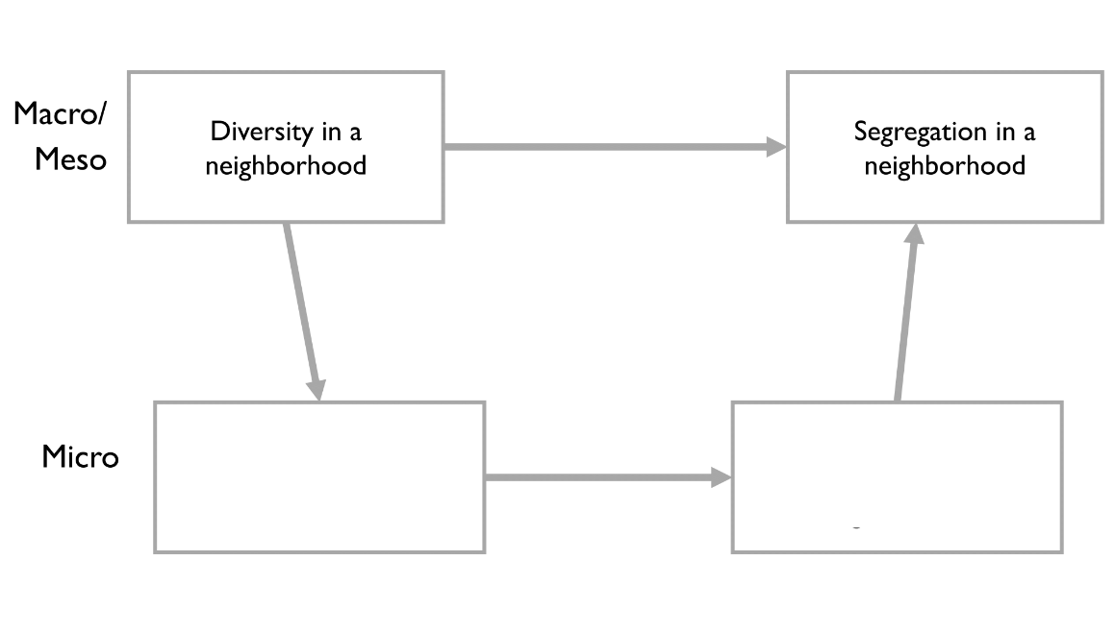

Answer:
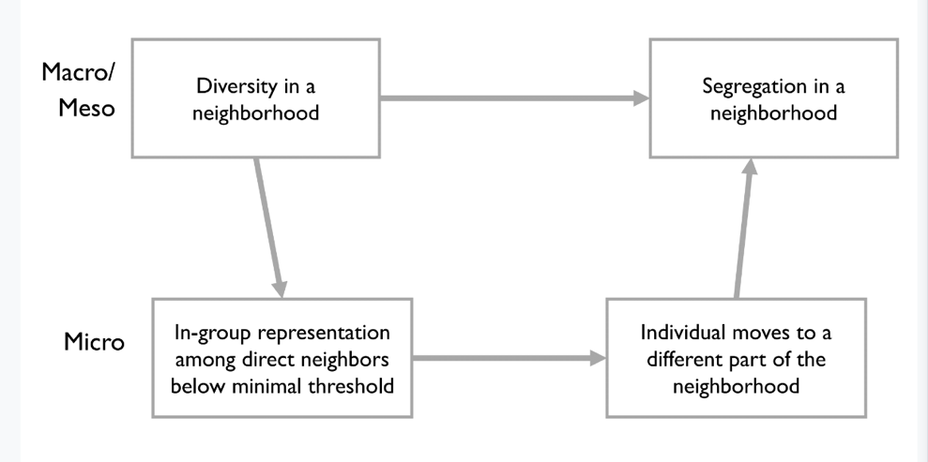

Q1c. What kind of micro-to-macro aggregation takes place here? Simple or complex?
Answer:
This is a prime example of interdependent actors, leading to complex aggregation: the decision of one neighbor to move due to low in-group representation leads to different conditions for yet another neighbor. While this neighbor may have been satisfied in the first situations, now that their original in-group neighbor has moved away, they will be looking for a new place to live as well. This creates a dynamic interplay between individuals and their contexts, such that we cannot simple aggregate individual characteristics to get collective outcomes.
Q1d. Chapter 11 refers to hyper-segregation as levels of segregation above 60%. Play around with the second simulation for a while. Can you figure out the threshold of preferences after which hyper-segregation is the common outcome?
Answer:
The threshold for hyper-segregation is a preference of having at least 33% of your neighbors being similar to yourself. Anything higher than this leads to hyper-segregation, i.e. segregation levels above 60%, except when the threshold is very high, then people just keep on moving, as they keep being unsatisfied.
Q1e. Now play the final two simulations (so not the sandbox just yet!). Can you translate the findings from the final simulation to a real-world policy implication?
Answer:
The proposed policy implication should emphasize that a small demand for diversity can help defy the emergence of segregation, all other circumstances remaining equal. Rather than being content with 100% homogeneous surroundings, even a preference for at least 1% diversity in the Schelling models makes it so that segregation levels don’t rise above 30%. In the real world, this may be realized by stimulating people to appreciate and require diversity even to the most minor degree. So, what does help, is if people have a preference to not live in a neighborhood with > 80% of their own group. So, a bit of demand for diversity (anti-bias) reduces segregation.

Q2
Read the following article, published in The Conversation: https://theconversation.com/banning-faith-schools-is-no-quick-fix-to-social-segregation-38797
Q2a. Which dimensions of integration are considered to be problematic among students at faith schools, according to this article? Give an example of the problematic aspect for both.
Answer:
Both social and cultural integration are deemed to be lagging behind among students at faith schools, compared to other schools. Social integration is lagging behind, since students at faith schools do not interact with members of other communities. Cultural integration is furthermore lacking since students at faith schools get limited education in the host society culture, instead focusing more on their specific religion and values.
Q2b. What policies are mentioned in the article to improve levels of integration between faith school students and other students?
Answer:
Some of the policy suggestions are the following: (1) Schools should promote intergroup cohesion by drawing in students from different backgrounds. (2) Students should get education not only about the religion the school affiliates with, but also others. (3) Faith schools should be cut off from governmental financial support. (4) Faith schools should be banned all together.

