Introduction to Sociology

Chapter 5 “Opinions”: Assignments

5.2 Self-fulfilling prophecy

Q1.
Suppose you have a headache from reading a particularly lengthy chapter of a Sociology textbook and decide to take an aspirin. The moment you decide to take the pill, you immediate feel your headache alleviate. Explain in your own words why this must be a case of a placebo effect and relate it to the Galatea effect.

Q2.
Consider the following situation. You are not extremely talented in statistics, but you have a statistics exam. You cheated and managed to get an exceptional high grade. Because of this, the teacher selects you for the Math Olympiad that’s coming up next month. You receive extensive additional training for the Olympiad, and everyone is expecting much of you. Working together with others on a daily basis also helps your understanding of math concepts and you end up third in the math contest. Is this an example of the Galatea effect or the Pygmalion effect? Explain.

5.3 Conformity

Q1.
In the 1950s and 1960s, Asch conducted a series of lab experiments on conformity.
Q1a. What did the Asch experiments on conformity show?
Q1b. Can you relate the outcomes of the Asch experiments to situations outside the lab, such as peer dynamics in school?
Q1c. Which two mechanisms explain conformity, according to Asch?
Q1d. Can you give examples of ‘negative social influence’?

Q2.
Consider the processes of peer transmission, parental transmission, and media transmission.
Q2a. Now think about the opinions and behavior of students from your university. What do you think is the most important source of their opinions and behavior? Peers, parents, media? Explain your answer.
Q2b. Has the importance of parents in influencing the opinions and behavior of children changed in the past 10 years?
Q2c. Why is “social influence” a broader concept than “conformity”?

5.4 Informational and normative social influence

Q1.
A distinction is made between informational and normative social influence. Recall the different processes of peer transmission, parental transmission and media transmission. Which type of process is mainly informational social influence? And which ones are subject to normative social influence?

5.5 Social learning theory

Q1.
Cristiano Ronaldo, Selena Gomez, Kylie Jenner are top ‘influencers’ on social media channels such as YouTube and Instagram, each having more than 100 million followers. They may influence people’s opinions, lifestyle, fashion, consumption preferences, and much more.
Q1a. Argue why the social influence of these top-3 influencers (Ronaldo, Gomez, and Jenner) may depend on age categories in society. Which social learning bias(es) is (are) important to consider here?
Q1b. Suppose that a top-influencer makes a silly suggestion, e.g. to wash your hair with eggs! According to which mechanism are these opinions unlikely to be copied by their followers?
Q1c. Imagine that elections are coming, and that top-influencers publicly make recommendations on which party one should vote; they post pictures and videos of their preferred party, and so forth. Suppose they suggest their followers to vote for party A. Why is it that social learning theory need not be refuted, when research findings indicate that a significant proportion of the followers decide to vote for another party instead?

5.6 Popularity of cultural products

Q1.
Salganik and Watts created artificial websites, to find out why some music songs become so popular. They examined the role of informational social influence. Suppose you want to study more specifically whether status bias plays a role in the popularity of music songs.
Q1a. Could you think of a way of repeating the experiment from Salganik & Watts, but then examine the impact of status bias?
Q1b. In their study, Salganik & Watts not simply differentiated between the ‘independence condition’ and the ‘social influence condition’. Rather, they also divided the social influence condition into two different types: (1) conditions in which a visitor of the website could see the ranking of the songs in descending order based on the number of downloads and (2) conditions in which the visitor could see the number of downloads next to the songs, but without ordering this from most popular to least popular. In which of these two influence conditions do you expect the largest discrepancy in the popularity of the most popular song and the least popular song towards the end of the experiment? Explain your answer.

5.7 Diffusion of innovations

Q1.
In their 1957 paper, Coleman, Katz and Menzel set out to test how ‘contagious’ the spread of a new medical innovation was among physicians.

Q1a. Why is it important that we understand the process of adoption of a new medicine among physicians? What is the social problem we may hope to solve? Explicate why this problem is a social problem (see Chapter 1).
Q1b. Below, you see part of their findings. Figure 1 reveals the cumulative adoption rate over time for two types of doctors: patient-oriented doctors and profession-oriented doctors. The first group is characterized by their main concern for the respect one receives from patients and one’s standing in the community, whereas the second group is characterized by their main concern for collegial recognition and research output. Describe what you observe and give an explanation for their findings.
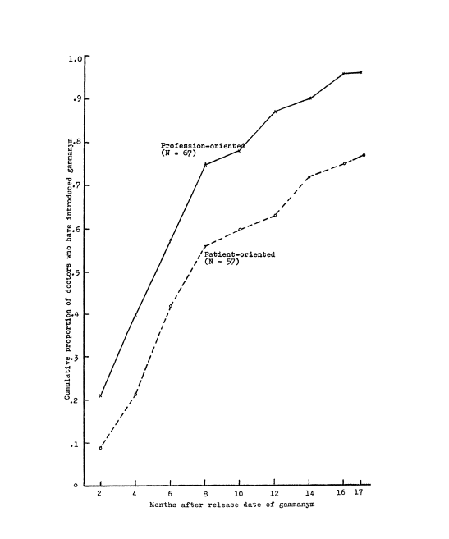

Q1c. Figure 2 presents another finding of the study. Again, we see the cumulative adoption rate over time. This time, the three lines represent doctors that were nominated as a friend by other colleagues once, twice, or three times respectively. Again, describe what you observe and give an explanation, using the insights you have gained in this chapter.

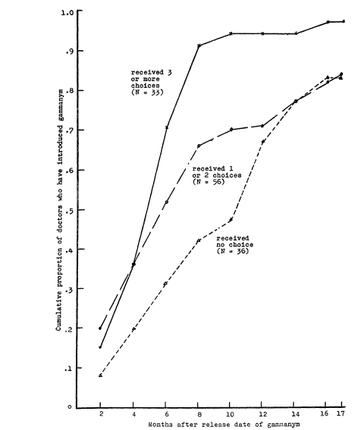

Chapter generic assignments

Q1.
Please read the following article about ADHD:
https://theconversation.com/youngest-in-class-twice-as-likely-to-take-adhd-medication-71331
Q1a. What would be an individualistic perspective on ADHD?
Q1b. What counterevidence does the article provide, that goes against the premises of the individualistic perspective?
Q1c. Could you relate the Galatea effect to the impact an ADHD diagnosis may have for a child (e.g., for self-identity, educational outcomes)?

Q2.
In contemporary western societies, women are underrepresented among CEOs.
Q2a. In what way could you use the Galatea effect and the Pygmalion effect to understand the position of women in the labor market? Can you use these two ideas to understand why women are underrepresented among CEOs?
Q2b. Can you represent your explanation using a multilevel framework (see Chapter 4)?

