Introduction to Sociology

Chapter 5 “Opinions”: Assignments with answers

5.2 Self-fulfilling prophecy

Q1.
Suppose you have a headache from reading a particularly lengthy chapter of a Sociology textbook and decide to take an aspirin. The moment you decide to take the pill, you immediate feel your headache alleviate. Explain in your own words why this must be a case of a placebo effect and relate it to the Galatea effect.
Answer:
The answer should contain the following. (1) Feeling alleviation directly upon deciding an aspirin must be a placebo effect because the real medicinal effects of the pill do not occur before taking it. (2) The Galatea effect refers to the situation where a self-fulfilling prophecy occurs because of self-expectations. (3) The expectation that taking the pill causes alleviation of the headache will generate a feeling of alleviation, which is an example of the Galatea effect.

Q2.
Consider the following situation. You are not extremely talented in statistics, but you have a statistics exam. You cheated and managed to get an exceptional high grade. Because of this, the teacher selects you for the Math Olympiad that’s coming up next month. You receive extensive additional training for the Olympiad, and everyone is expecting much of you. Working together with others on a daily basis also helps your understanding of math concepts and you end up third in the math contest. Is this an example of the Galatea effect or the Pygmalion effect? Explain.
Answer:
This is an example of the Pygmalion effect. The expectations that others have of you shape a self-fulfilling prophecy. Because the teacher thinks you are good at statistics and math, you gain a lot of extra training, which causes you to actually become good at statistics.

5.3 Conformity

Q1.
In the 1950s and 1960s, Asch conducted a series of lab experiments on conformity.
Q1a. What did the Asch experiments on conformity show?
Answer:
That people often conform to the judgement of the majority group, even when the majority judgement is false.

Q1b. Can you relate the outcomes of the Asch experiments to situations outside the lab, such as peer dynamics in school?
Answer:
Sociological studies on youth show that students tend to copy the behaviors of their peers, similar to what happened in the lab studies of Asch. It is the process of conformity.

Q1c. Which two mechanisms explain conformity, according to Asch?
Answer:
Informational and normative social influence.

Q1d. Can you give examples of ‘negative social influence’?
Answer:
Examples: if peers in class start drinking/smoking/etc., other students in class stop drinking/smoking/etc. If parents do X, kids do not-X, etc.

Q2.
Consider the processes of peer transmission, parental transmission, and media transmission.

Q2a. Now think about the opinions and behavior of students from your university. What do you think is the most important source of their opinions and behavior? Peers, parents, media? Explain your answer.
Answer:
Open to discussion. Answer depends on, amongst others, the type of opinions and behavior (e.g., drinking behavior or religiosity), on the amount of exposure to peers, parents and media (according to social learning theory).

Q2b. Has the importance of parents in influencing the opinions and behavior of children changed in the past 10 years?
Answer:
Open to discussion. Answer depends on, amongst others, the changing amount of exposure to parents, and to the changing status of parents (according to social learning theory).

Q2c. Why is “social influence” a broader concept than “conformity”?
Answer:
Conformity refers to positive social influence. Social influence can also pertain to negative social influence, which is the opposite of conformity.

5.4 Informational and normative social influence

Q1.
A distinction is made between informational and normative social influence. Recall the different processes of peer transmission, parental transmission and media transmission. Which type of process is mainly informational social influence? And which ones are subject to normative social influence?
Answer:
Media transmission is often informational and not normative, because the mechanism of approval and sanctioning does not apply here. Parental and peer transmission are often a combination of informational and normative social influence.

5.5 Social learning theory

Q1.
Cristiano Ronaldo, Selena Gomez, Kylie Jenner are top ‘influencers’ on social media channels such as YouTube and Instagram, each having more than 100 million followers. They may influence people’s opinions, lifestyle, fashion, consumption preferences, and much more.
Q1a. Argue why the social influence of these top-3 influencers (Ronaldo, Gomez, and Jenner) may depend on age categories in society. Which social learning bias(es) is (are) important to consider here?
Answer:
Particularly younger age groups are likely to follow these celebrities (exposure), and to regard them as high status figures (status bias), as compared to older people (who may not be so active on social media, and/or not admire these celebrities as much as younger people do).
Q1b. Suppose that a top-influencer makes a silly suggestion, e.g. to wash your hair with eggs! According to which mechanism are these opinions unlikely to be copied by their followers?
Answer:
Adaptation bias: people tend to copy opinions that make sense.
Q1c. Imagine that elections are coming, and that top-influencers publicly make recommendations on which party one should vote; they post pictures and videos of their preferred party, and so forth. Suppose they suggest their followers to vote for party A. Why is it that social learning theory need not be refuted, when research findings indicate that a significant proportion of the followers decide to vote for another party instead?
Answer:
Social learning theory argues that people copy opinions from their environment. The environment consists not only of influencers on social media, but also: parents, peers, and so forth. Moreover, the social learning biases may act as counterforces. For example, the suggestion to vote for party A may run counter to confirmation bias (i.e., when followers have voted for other parties before, they may not easily switch to A), and adaptation bias (it may be seen as a mistake to vote for A)

5.6 Popularity of cultural products

Q1.
Salganik and Watts created artificial websites, to find out why some music songs become so popular. They examined the role of informational social influence. Suppose you want to study more specifically whether status bias plays a role in the popularity of music songs.
Q1a. Could you think of a way of repeating the experiment from Salganik & Watts, but then examine the impact of status bias?
Answer:
To study the possible influence of status bias, the website could mention that certain songs are endorsed by certain celebrities, music experts, or other high-status figures. By randomly assigning songs to such endorsement of high-status figures, one could examine whether status bias plays a role. If so, then songs approved by high-status figures should become more popular.
Q1b. In their study, Salganik & Watts not simply differentiated between the ‘independence condition’ and the ‘social influence condition’. Rather, they also divided the social influence condition into two different types: (1) conditions in which a visitor of the website could see the ranking of the songs in descending order based on the number of downloads and (2) conditions in which the visitor could see the number of downloads next to the songs, but without ordering this from most popular to least popular. In which of these two influence conditions do you expect the largest discrepancy in the popularity of the most popular song and the least popular song towards the end of the experiment? Explain your answer.
Answer:
It is expected (and indeed observed) that the largest peak in popularity occurs in the conditions where the music downloads are ranked from most popular to least popular. It is here that the cumulative advantage based on popularity bias is arguably strongest, due to the optimal contextual facilitation for this mechanism: it is very easy for visitors of the website to directly see what is the most popular song.

5.7 Diffusion of innovations

Q1.
In their 1957 paper, Coleman, Katz and Menzel set out to test how ‘contagious’ the spread of a new medical innovation was among physicians.

Q1a. Why is it important that we understand the process of adoption of a new medicine among physicians? What is the social problem we may hope to solve? Explicate why this problem is a social problem (see Chapter 1).
Answer:
If there is a new, well-functioning drug on the market and it is not adopted by doctors, people may unnecessarily suffer. This is a social problem because it affects (many) people and conflicts with common values in society (that no one should suffer from poor health).

Q1b. Below, you see part of their findings. Figure 1 reveals the cumulative adoption rate over time for two types of doctors: patient-oriented doctors and profession-oriented doctors. The first group is characterized by their main concern for the respect one receives from patients and one’s standing in the community, whereas the second group is characterized by their main concern for collegial recognition and research output. Describe what you observe and give an explanation for their findings.
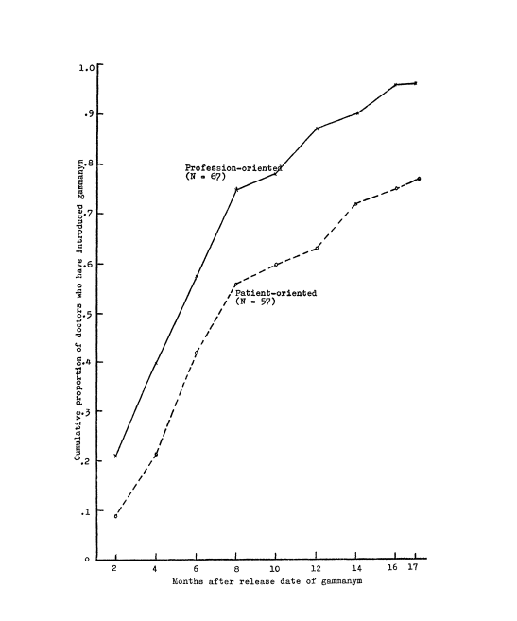
Answer:
The figure shows that the cumulative adoption rate of profession-oriented doctors is faster and higher than that of patient-oriented doctors. One explanation might be that profession-oriented doctors read a lot of scientific journals (exposure bias), and they value researched-based medicine more (status bias) than patient-oriented doctors.

Q1c. Figure 2 presents another finding of the study. Again, we see the cumulative adoption rate over time. This time, the three lines represent doctors that were nominated as a friend by other colleagues once, twice, or three times respectively. Again, describe what you observe and give an explanation, using the insights you have gained in this chapter.

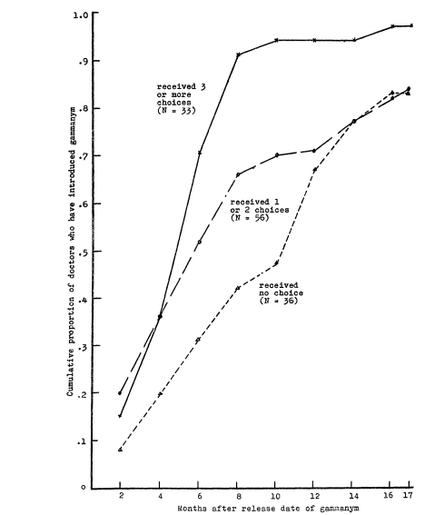

Answer:
We see that the adoption rate is faster and higher for well-embedded physicians. A sociological explanation based on Chapter 5 may include theories and concepts related to diffusion of information, complex contagion, and conformity. For example, using a new drug may be seen as risky, as complex contagion, hence doctors are hesitant to use it without talking to friends who used it.

Chapter generic assignments

Q1.
Please read the following article about ADHD:
https://theconversation.com/youngest-in-class-twice-as-likely-to-take-adhd-medication-71331
Q1a. What would be an individualistic perspective on ADHD?
Answer:

From an individualistic perspective, ADHD would be viewed as a neurobiological disorder.

Q1b. What counterevidence does the article provide, that goes against the premises of the individualistic perspective?
Answer:

The authors mention (1) birth order effects. Kids born in June (the youngest in class) were “about twice as likely (boys 1.93 times, girls 2.11 times) to have received ADHD medication as those born in the first intake month (the previous July).” If this is true, it means that the diagnosis ADHD depends on other factors that pure genetics, that, actually, the youngest kids may get this diagnosis wrongly. The authors also mention (2) “other risk factors for receiving medication for ADHD include race, class, postcode and clinician, teacher and parental attitudes; none of which have anything to do with a child’s neurobiology.” And (3) “rapidly increasing child ADHD prescribing rates in Australia and internationally”, which seem to suggest that broader societal changes are driving ADHD diagnoses.
Q1c. Could you relate the Galatea effect to the impact an ADHD diagnosis may have for a child (e.g., for self-identity, educational outcomes)?
Answer:
Some children do have attention deficiencies, but the authors also report cases of overdiagnosis. The Galatea effect argues that self-expectations impact how one will behave. Children diagnosed with ADHD may perceive themselves as being ‘medically problematic’, as having a ‘psychiatric disorder’. Such self-perceptions can possibly lead to negative self-concept and hamper school outcomes.

Q2.
In contemporary western societies, women are underrepresented among CEOs.
Q2a. In what way could you use the Galatea effect and the Pygmalion effect to understand the position of women in the labor market? Can you use these two ideas to understand why women are underrepresented among CEOs?
Answer:
Women may have lower self-expectations than men (Galatea) and/or others may expect less of women with respect to the top positions in the organization (Pygmalion effect). These effects may work interdependently, i.e. people have lower expectations of women, which leads to lower self-expectations (which in turn may impact behavior and in the end even impact others beliefs).
Q2b. Can you represent your explanation using a multilevel framework (see Chapter 4)?
-
Share women in CEO positions in society
Stereotype views about
women in society
Lower self-expectations
women

+
+
Pygmalion effect

Galatea effect
Apply for CEO positions

-

